Caleb Javier
Adrianna Holden-Gouveia
Linux Administration
14 September 2025

Documentation: Server Setup
This documentation will outline the utilization of VirtualBox to set up two different distributions of Linux servers (CentOS and Debian).

Installing virtual machine software
The software used to host these servers will be VirtualBox.
To set up,
- Install VirtualBox here. Click the corresponding operating system of the machine you are using. This document will demonstrate the installation for Windows.
- Run the installer and go through the setup. During setup, all default configurations are okay to proceed with.
- After the installation is complete, run VirtualBox.

CentOS
In order to set up a virtual server, a distribution must be obtained from the web. An ISO of CentOS can be downloaded here - in this example, the latest version for the x86_64 architecture. The .iso format is necessary for the VirtualBox setup.
- In the VirtualBox interface, select the “New” button.
  - Set the name as something identifiable, preferably denoting CentOS.
  - The VM Folder can be left as default.
  - The ISO file downloaded from centos.org will be selected as the image. Navigate to it using the dropdown. The ISO file will also automatically set the OS configurations, which should read as such:
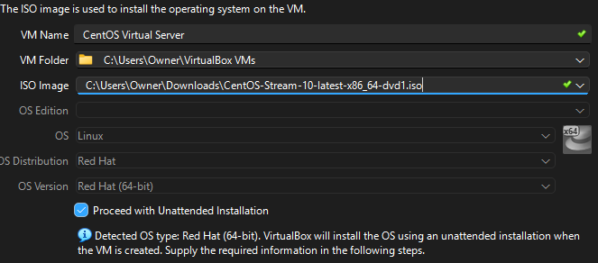
- Uncheck “Proceed with Unattended Installation” to proceed.
  - Specify the virtual hardware: set memory to 4 gigabytes, virtual CPUs to 2, and allocate at least 20 gigabytes for the virtual hard disk drive for optimal space and comfortability. In this example 60 gigabytes have been allocated.
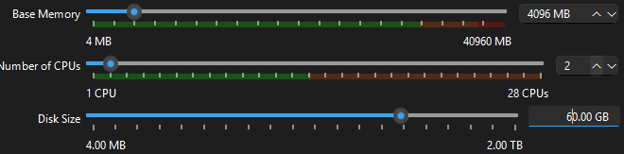
- Select “Next” to review a summary of the configurations, and select
“Finish” to finalize the creation of the virtual server.
- It is now ready to power on. Select “Start” and allow the machine to arrive at boot screen. Using the keyboard, navigate to and press enter to boot using this option. The machine will load and begin booting.
- The console will provide a GUI to complete setup. Using the keyboard and mouse, select the preferred language and proceed.
- Select , and enable the root user. Set a password and document securely. Check “Allow root SSH login with password” .
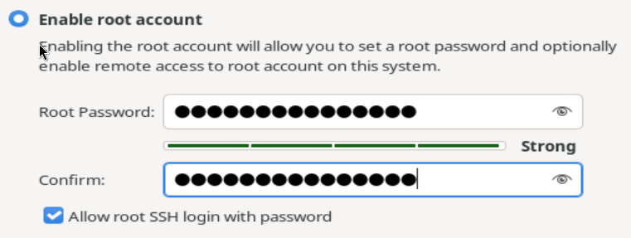
- Navigate to “Done” to proceed. Address warning in “Installation Destination”  by entering the menu. The default configuration is okay, navigate to Done once more.
- Create a memorable user by entering the “User Creation” menu .
These settings are fine. Click Done again.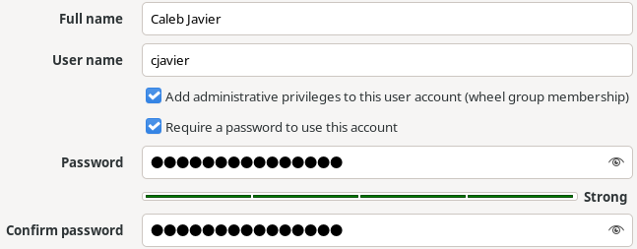
- Next navigate to “Software Selection”. Move the selection to “Server” 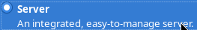, as no GUI will be used for this. Navigate to Done once more.
- With these configurations complete, the server can now fully be installed. Select “Begin Installation which will prompt with a reboot after it is completed.
- After booting, provide the user login and test the internet connection by pinging a live website.
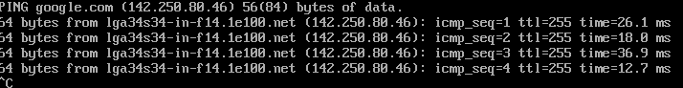
There is a healthy stream of packet flow with zero loss. The default network
settings for VirtualBox should allow this.

- Finally, to establish file sharing capabilities, the SmarTTY program will be downloaded and installed normally as it instructs in the wizard.
- After enabling SSH services and confirming that it is running using these commands,
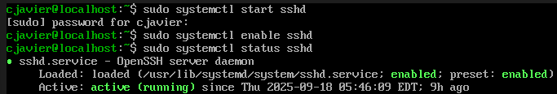
find the IP address of the server by using ifconfig or ip a. Once complete, the connection is ready to be made.

Debian
- Similarly to CentOS, Debian 13’s ISO will be downloaded online here.
  - Repeat the steps to create the VirtualBox machine - the specifications/allocations will also work for this machine (4GB RAM, 2 CPU, 60GB HDD).
  - Finish the setup and launch the Debian server. Navigate to and begin the “Graphical install” . Begin by selecting the language, location, and keyboard layout, and click “Continue” .
  - Debian will load components and configurations for a moment, then prompt to be named. In this case, “debianvirtualserver” was chosen.
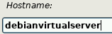
Then, Choose a memorable hostname to complete network configuration. In this case, “debianserver.com” was chosen.
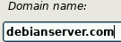
  - Create the root password and administrator user just as with CentOS. The process is very similar. In this case, the username was changed to the same format as with CentOS (cjavier instead of caleb).
    - Select “user entire disk” when prompted to partition the disks and continue. Select “All files in one partition” , then “Finish partitioning and write changes to disk” .Confirm the final summary by selecting “Yes” then continue. The base system will now install.
  - Select “No” for the next three prompts (network mirror, survey participation). Continue again. When selecting software to be installed, uncheck “desktop environment” and check SSH server. This is absolutely necessary to installing Debian as a server only. Click continue, and the installation continues.
  - Select the hard disk drive when installing the GRUB boot loader. Debian’s installation will finalize and finally reboot.
- Test the internet connection: use ifconfig to verify that the IP address has been issued, and ping a website in order to confirm.
- File transfer - This will need to be resubmitted. I am working on this currently.

